ROOKLEY VILLAGE NEWS
Christmas 2024

DIARY DATES:
‘Light up a Life’ Carols with Guitar accompaniment | Monday 9th December at 18.30 on the Village Green
Rookley Village Association AGM – open to the public | Monday 16th December at 18.30 in the Village Hall, Highwood Lane
Parish Council meetings – open to the public | First Wednesday each month (except August and January) at 19.30 in the Village Hall
Rookley WI | Second Thursday each month in the  Village Hall

This newsletter is prepared and distributed jointly by Rookley Parish Council and Rookley Village Association (RVA). The RVA website at www.rookley.org is also used by the Parish Council to meet its statutory disclosure obligations and provides details on upcoming Parish Council meetings and the Minutes of same.
The RVA Facebook page provides regular updates on news and events which may be of interest to residents – and, according to the number of ‘views’ it gets, to a much wider community.

Parish Council Update:
Our thanks go to Cllr Liz Wills for her hard work as Chair to the Parish Council, and also for her time acting as Parish Clerk. Liz was replaced as Chair, by Cllr Colin Willis, at the September Parish Council meeting and Cllr Ian Leah became Vice-Chair.
Ian and Terry Caws joined the Parish Council at the beginning of the year, and are residents of Highwood Grove. Terry has unfortunately resigned from the Parish Council in order to concentrate on his RVA roles. This has subsequently created a vacancy on the Parish Council.
We welcomed a new Parish Clerk and Finance Officer in June this year. Sally Woods is a well experienced Clerk, who has previously worked for Totland, Freshwater and Shalfleet Parish Councils.
Cllrs Ian Leah and Terry Caws have both been active regarding the Wastewater Treatment Plant in Highwood Lane, and flooding problems.
The Parish Council have discussed and taken action on various matters, including speeding in the Village, a meeting with Cyclewight to upgrade the surface of bridleway A37, a replacement of a new dog bin on the Niton Road, regular liaison with the Environment Officer over litter and the skate park, and continuing dialogue with agencies over a new footway linking Highwood Grove to the village. A new Policy for the Village Green is to be drawn up by the Chair and Vice-Chair for the Council to agree at a future meeting. This to include seats, benches, plaques, trees, memorials and the time capsule.
Christmas ‘Light up a Life’ Carol Service on the Green last year, in aid of Earl Mountbatten Hospice, was extremely well attended, despite the muddy conditions. The collection raised £172.25, with the Council donating another £150. Thanks to Revd John Izzard for carrying out the service, Cllr Mike Jones for arranging the guitar group to accompany the carols and Graham Filer for providing a generator to light the way.
Parish Council:
Chair: Colin Willis Tel: (01983)721030 Email: colin_j_willis@hotmail.co.uk
Vice-Chair: Ian Leah Email: ianleah@icloud.com
Cllrs: Mike Jones, Ian RigaudBarrett, Liz Wills, Alex Watts
Clerk: Sally Woods Tel: 07871458378 Email: parishclerk@rookley.org
IW Ward Cllr: Suzie Ellis Email: suzie.ellis@iow.gov.uk

Isle of Wight Society Conservation Award
The major Isle of Wight Society Conservation Award was presented for the work achieved at The Old Tin Hut, Rookley. Here, a derelict “Tin Tabernacle,” a Boulton and Paul “flat pack” chapel of 1882, has been carefully rebuilt incorporating the original designs. It now provides an excellent two bedroomed house with A rating energy efficiency.
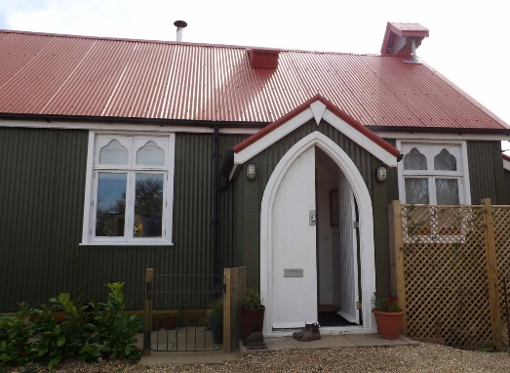

P.R.I.D.E. Awards
We are delighted that our very own Susan Willis was recently presented with the ‘Village P.R.I.D.E. Award 2024’, in the Isle of Wight Best Kept Village Awards. The Village P.R.I.D.E. Award stands for Preservation, Renovation, Innovation Dedication or Education and it was presented to Susan by the Isle of Wight High Sheriff, Graham Biss.
She was awarded it for “the dedicated voluntary services she provides in Rookley that greatly benefits the residents”.
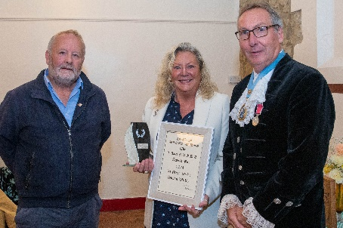
This included the upkeep of flower beds and the support she set up and provided to the village during the Covid pandemic.
Congratulations Sue, your award is very well deserved.

Sue asks: If you are growing plants from seed for the coming year it would be much appreciated if you could put a few aside for the flower beds on the village green.
If you are passing, please feel free to pull a weed or three, and dead-heading (the spent flowers!!) would be much appreciated.
And last but not least if you are able to spare a drop or watering can full of water especially in dry weather the flowers would love you eternally.
Please give Sue a buzz on 01983721030 and she will pick up any donations.

Rookley Village Association (Reg Charity No. 1136814)
A busy year has continued for the Rookley Village Association, and here are some highlights:
In an attempt to promote the clubs and activities that run regularly at the Rookley Village Hall and grounds over the year, a coffee morning was organised early in March. Representatives from the various clubs were on hand and the morning proved highly successful, resulting in the event attracting a good number of new members for the clubs.
The coffee morning was the associations contribution to the National Village Halls week initiative which was billed as celebration of: ‘village life & future sustainability’. This culminated in our own display of Rookley Village’s offerings to the local community displayed at Mottistone Manor in March.
Gardening Galore returned to the events calendar in June. The event was a great success and well organised, mainly due to the local volunteers, without whose help this could not run. The feedback was extremely positive and sealed its
place as one of best gardening events in the Islands calendar, with a date in the diary of 4th May 2025 for its return.
Initially, as a thanks to our volunteers the: ‘Friends of the RVA’ was launched with the intention of running regular social events starting with a Quiz Night held in August. The event was a resounding success and has already become a very popular regular event with the local community.
In our plans for the new year will be the addition of ‘Race Nights’ which we know to be popular events, with first one a date in January to be confirmed.

At the heart of all these events are volunteers who are a vital part of any charitable organisation such as ours. We are always in need of help and would be delighted to hear from anyone who would be prepared to give up any amount of time to help out, even very occasionally. In particular we are currently searching for someone with accountancy experience who can become our Treasurer going forward.
If you would be interested in any aspect of our activities, or maybe able to help as a volunteer, please email: secretaryrva24@gmail.com we would be delighted to hear from you.

Rookley Village Association
Chair: Tim Marshall Tel:(01983) 721557 Email: tim@rookley.net
Treasurer: Karen Stewart Tel: (01983) 721830
Secretary: Terry Caws Tel: 07796848770 Email: secretaryrva24@gmail.com

Rookley Women’s Institute
President: Angela Johnson Tel: (01983)721393

Many thanks to the anonymous person who kindly provides the post box toppers in the Village, they are much appreciated and enjoyed:

